**Muscle Exercise 31P MRS: Simplified Workflow Description**

**Paweł Tokarczuk – Robert Steiner MRI Suite – February 2019**

**Introduction**

To use the MATLAB script efficiently, begin by collecting your studies together in a common top-level project folder as follows:

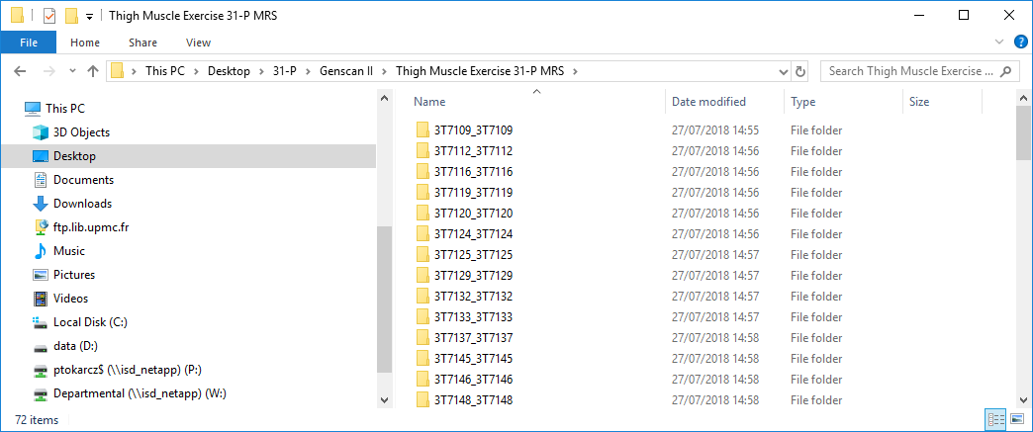

The sub-folders have the same name as the scanner ID for the study (locally, the “3T number”), but doubled with an underscore (this is an artefact of data export from a Siemens scanner onto an external drive). In each sub-folder (perhaps several levels down) there should be a folder that actually contains the 240 free induction decays from the exercise scan, which is generally the last scan acquired in the course of an exam.

Within your MATLAB workspace, you should also have an XLSX file to match the scanner ID to the subject ID; for an anonymized subject called Alex Brown, this might be something like **14AB01234**.

The MATLAB workflow is now very simple. Look for the file called **pft\_MainScript** and make sure that its containing folder (and all the sub-folders beneath it recursively) are on the MATLAB path. On running the script, you will be prompted for the top-level folder just described, after which, the analysis will proceed automatically for all the studies within it. After some initial pre-processing – such as filtering and automated phase-correction – the script will produce a summary file at the same level as the FID’s within a study. The decorated name will consist of the scanner ID, the subject ID, and the word “SUMMARY”, e.g.:

**3T0001 – 14AB01234 – SUMMARY.pdf**

There will also be some “auditing” files, in a variety of formats but with essentially the same content, for possible later re-use (in MS Word documents, PPT presentations, Web documents, etc.).

In general, the summary file will consist of the following three pages:

1. The time-course of the PCr and inorganic phosphate signals (calculated from the integrals of the phase-corrected spectral peaks).
2. A zoomed plot of the PCr time-course for exercise bout 1, with least-squares mono-exponential and bi-exponential fits to the recovery phase.
3. A similar plot for bout 2.

If the curve-fitting should fail, then one or both of the final two pages will be missing.

The results will also be collated in an XLSX file within the top-level folder called:

**Exercise 31-P MRS Summary.xlsx**

If this does not exist when the analysis begins, then it will be created. Note that the file contains several tabs. This is your starting point for any higher-level analysis. You might look for differences between the two bouts of exercise (due to habituation or fatigue), or between genotypes/phenotypes (if you have the relevant subject information).

Once the main script has run to completion, you can join the SUMMARY files together to create a grand compilation. Start by opening a File Explorer and searching for “**\* SUMMARY.pdf**”; then, select all the entries which appear, perhaps copy them to a temporary folder, and finally combine them with Adobe Acrobat Pro. Make sure to sort the input files into ascending or descending lexicographical order.

The following pages show the output from one sample study:

C:\Users\ptokarcz\Desktop\Processed MRS Results\3T7109_3T7109\MRI_LEG_SPECTROSCOPY_20180412_110714_142000\MUSCLE_DYN_FID_IN-VIVO_0009\Time-Course Plots.emf

**Fig. 1. The time-course of the integrated PCr and Pi peaks.**

**C:\Users\ptokarcz\Desktop\Processed MRS Results\3T7109_3T7109\MRI_LEG_SPECTROSCOPY_20180412_110714_142000\MUSCLE_DYN_FID_IN-VIVO_0009\Bout 1 Curve-Fitting.emf**

**Fig. 2. Recovery curves fitted to the data for exercise bout 1.**

**C:\Users\ptokarcz\Desktop\Processed MRS Results\3T7109_3T7109\MRI_LEG_SPECTROSCOPY_20180412_110714_142000\MUSCLE_DYN_FID_IN-VIVO_0009\Bout 2 Curve-Fitting.emf**

**Fig. 3. Recovery curves fitted to the data for exercise bout 2.**